Domestic abuse – help and support for victims and perpetrators

Everyone should feel safe at home. For anyone who feels they are at risk of abuse, it is important to remember that there is help and support available to you, including police response, online support, helplines, refuges and other services.

If you or someone else is in immediate danger please call 999 and ask for the police. If you are not safe to speak – for mobiles use the Silent Solution system: call 999 then press 55 when prompted. If you can’t use a voice phone, register with the police text service - text REGISTER to 999. You will get a text which tells you what to do next. Do this when it is safe so you can text when you are in danger

Here are the details of local support services:

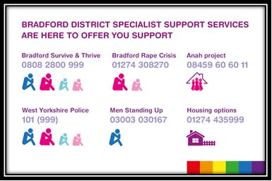

North Yorkshire Domestic Abuse Services: IDAS https://www.idas.org.uk/, 03000 110 110

Also available for advice & support are national services:

- The National Domestic Abuse helpline: Freephone 0808 2000 247 (24 hours a day) or online at https://www.nationaldahelpline.org.uk/
- Women’s Aid: online advice and support + live webchat https://www.womensaid.org.uk/
- Galop supports members of the LGBT+ community: Freephone 0800 999 5428 or email help@galop.org.uk.
- Male victims of domestic abuse: Freephone 0808 8010327 or online https://mensadviceline.org.uk/
- If you are hurting the one’s you love & want support & advice or you want help for your partner contact Respect: Freephone 0808 8024040 or online at https://respectphoneline.org.uk/

Anyone can be a victim of domestic abuse, regardless of gender, age, ethnicity, socio-economic status, sexuality or background.

GP practices are still here to help. Please telephone or submit an e-consultation via our practice website.

